Steam Cooking System at JNV Khumbathang - KARGIL
Technology | Single Auto Avertical Paraboloid dish type | 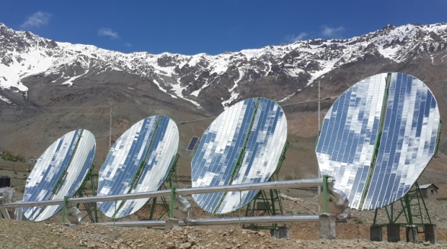  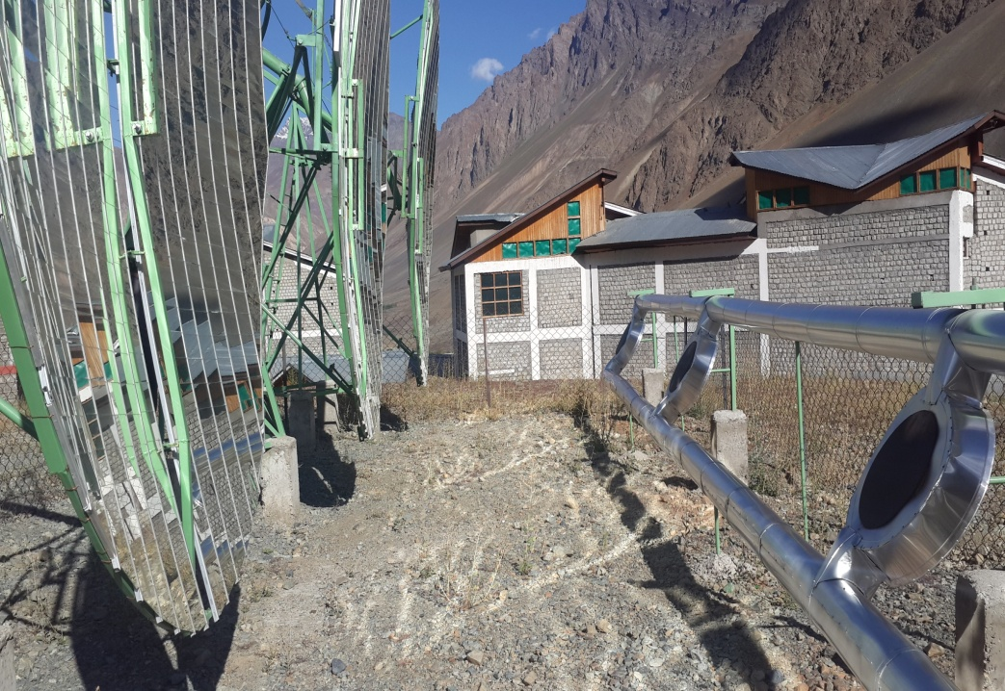
System Size | 64 sq. m. (04 Nos. of Dishes)
Application | Steam Cooking
Manufacturer | Unisun Technologies with SKL Leh
Sanction Dates | MNRE : 29.03.2014
Commissioning | 02.06.2017
Project Cost &  Support (Rs.) | Total :25.00 lakhs; MNRE :15.00 lakhs,  UNDP : 07.50; Beneficiary : 02.50 lakhs
Process | Steam generated being directly used for Cooking purpose. Earlier LPG cylender was being used.
Expected Savings | 70 kg of LPG per day.
Payback | 3 years approximately
Anticipated Co2  reduction | NA | 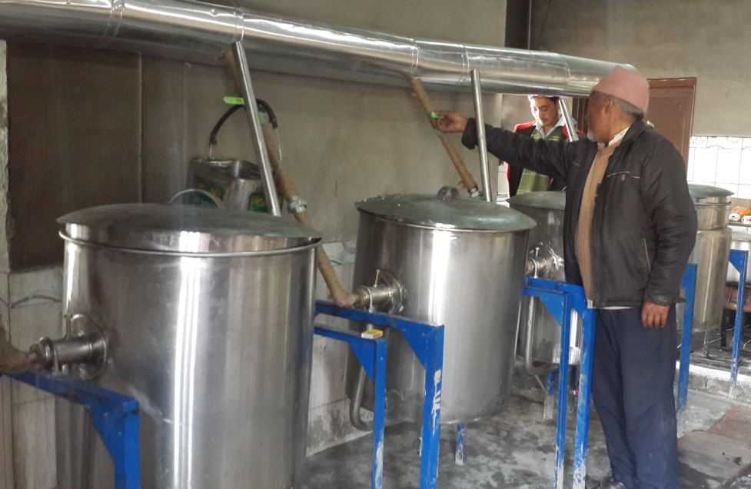
On- line  performance  establishment  if any | NA
Beneficiary’s  Contact details | Name : Principal JNV Khumbathang  Designation : Principal  Phone : 01985-278041  E-mail : jnvkgl@gmail.com

